Triboelectric Generator Model
http://triboelectricgenerators.weebly.com/ jkane 6/24/15 and 11/06/19

To Do: Work through this sheet and submit responses (#1-3, 13-22)

Pre-lab questions:
1. Describe when or where you have encountered static electricity.
2. With such a great need for energy today, why do you think this static electricity is not a provider of today’s energy needs?
3. If the objections you mentioned in #2 could be addressed, could static electricity be a great new energy source?

Background: In 2012 a nanotechnology engineer from Georgia Institute of Technology, Dr. Zhong Lin Wang, developed a way to capture and use static electricity to charge mobile devices and is currently working on applications to contribute to the world energy needs through applying this technology to ocean waves. He states, “This generator can convert random mechanical energy from our environment into electric energy.” He predicted that within five years this would be a viable energy option for some applications. The advantage of this energy source is that it is free, abundant, inexpensive to capture, and has many future applications. He called this device a triboelectric generator (TEG), and at the nanometer scale, a triboelectric nanogenerator (TENG). Static electricity generators usually produce high voltage and low current amounts. A similar generator, a piezoelectric generator uses pressure instead of static and usually produce low voltage and high current amounts. In March 2015 a group of scientists combined tribo and piezo effects in one device to increase the output even more. In the Sept/Oct 2019 issue of Discovery magazine, Dr. Wang is featured: https://discovermagazine.com/2019/septemberoctober/the-energy-scavengers

Purpose: In this investigation you will build a TEG device like Dr. Wang’s first one and explore the behavior of the generated voltage on a graph.

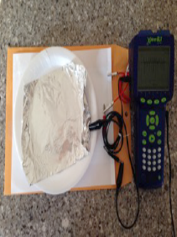
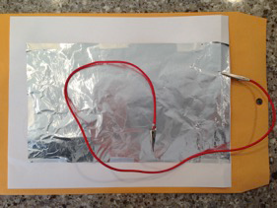
Materials per group:
2 6x10”Aluminum foil pieces
1 Styrofoam plate
2 alligator clips
1 graphing data logger
1 piece 8 x 11 inch paper
Tape
Non-conducting surface such as the paper envelope shown

Method:
4. Tape 1 foil to the paper so that paper extends beyond the foil on three edges and aligned close to the top along the 4th edge.
5. Attach 1 clip to the foil or foil and paper. (See picture above). Turn paper/foil over.
6. Tape the second foil to the inside of the plate.
7. Attach the second clip to a corner of the second foil.
8. Attach the clips to the graphing data logger set to record voltage.
9. Hold the plate so you are not in contact with the foil.
10. Move the plate, foil side up, up and down on the paper.
11. Observe the graph and experiment with how the plate motion affects the graph. Use your observations to maximize voltage.

Results:
12. Record the maximum voltage generated.
13. Sketch the graph of voltage vs. time for several voltage spikes.
14. Label the sketch to show when the plate is touching the paper, when it is moving towards the paper and when the plate it is moving away from the paper.
15. Note some of your observations. Example: if I lift the plate faster then___.

Conclusion:
16. What cause the voltage spikes in your generator?
17. What variables affect the change in voltage?
18. Which variable that you explored had the greatest affect on voltage?
19. What does Dr. Wang believe TENGs will be able to do?
20. How did Dr. Wang increase the voltage in his generators?
21. How have the TENG’s been modified since his original sliding and tapping motion?
22. Based on what you have learned, could this triboelectric generator be a viable energy resource? Explain.

http://www.news.gatech.edu/features/harvesting-worlds-mechanical-energy accessed: 6/24/15

